Patient Name:___________________________________________ Date:_____________
Appointment Time: _______________ Time of Arrival: ________________

- Do you understand your condition? Yes No
- Are you taking all of your medications as prescribed? N/A Yes No
- What makes your pain better? ___________________________________________________________________________________________________________________________________________
- What makes your pain worse? ___________________________________________________________________________________________________________________________________________
- Any medical changes or injuries since your last visit? Yes No
If yes, please explain:_____________________________________________________________________________________________________ _____________________________________________________________________________________________________________________________
- Do you understand the purpose of your home program? N/A Yes No
- Can you demonstrate your exercise program completely? N/A Yes No
- How consistently have you performed your home exercise program?
A B C D F
I’ve done exactly as instructed I have done half I have not done any of it

- How do you feel today compared to your last visit? BETTER SAME WORSE
/// Stabbing, Sharp
XXX Burning
000 Pins & Needles
=== Numbness
+++ Aching
- Circle the least and most pain
X over current pain

0 1 2 3 4 5 6 7 8 9 10
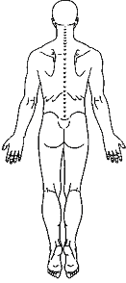
No Pain Emergency Room
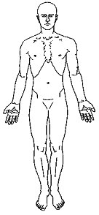

Please use the above symbols to mark on the diagram where you feel discomfort.

- Overall Percentage of Improvement from 1st visit
(0-100%): ___________

X________________________________________________
(Patient Signature) R L L R

